Hello Raj,

While we retest different scenarios thoroughly, I observed that the product code is not updated as per Jamila’s request:
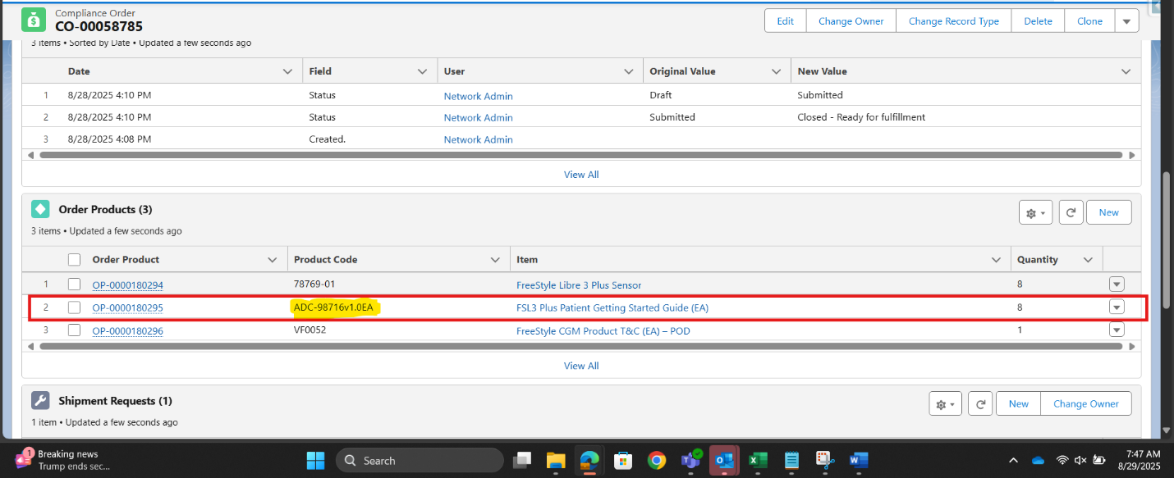
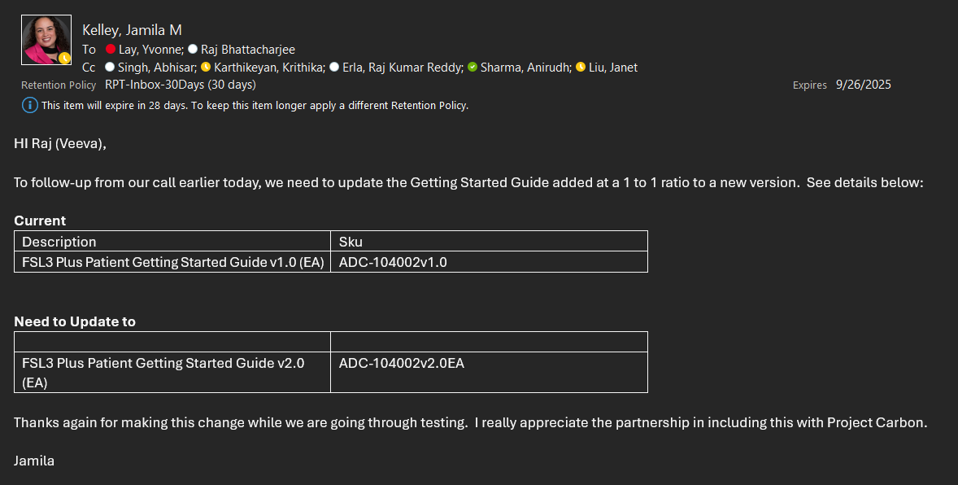

Could you please look into this?
Best,
Anirudh

From: Raj Bhattacharjee <raj.bhattacharjee@veeva.com>
Sent: Friday, August 29, 2025 5:49 AM
To: Sharma, Anirudh <anirudh.sharma1@abbott.com>
Cc: Lay, Yvonne <yvonne.lay@abbott.com>; Karthikeyan, Krithika <krithika.karthikeyan@abbott.com>; Madnani, Heena <heena.madnani@abbott.com>; Novodvorska, Kateryna <kateryna.novodvorska@abbott.com>; Erla, Raj Kumar Reddy <rajkumarreddy.erla@abbott.com>; Gupta, Muneeshwar <muneeshwar.gupta@abbott.com>; Kelley, Jamila M <jamila.kelley@abbott.com>; Liu, Janet <janet.liu@abbott.com>; Singh, Abhisar <abhisar.singh@abbott.com>
Subject: Re: Project Carbon – Testing Issues Identified

Seems like it worked. . . The Compliance order was created last night. -- Raj Bhattacharjee Veeva | Practice Manager, Commercial Technical Services On Fri, Aug 29, 2025 at 8: 36 AM Raj Bhattacharjee <raj. bhattacharjee@ veeva. com> wrote: Checking.
ZjQcmQRYFpfptBannerStart
This Message is From an External Sender
Only click links or open attachments if you recognize the sender and know the content is safe.
Report Suspicious ‌

ZjQcmQRYFpfptBannerEnd
Seems like it worked... The Compliance order was created last night.

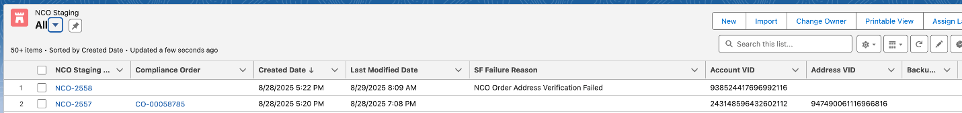

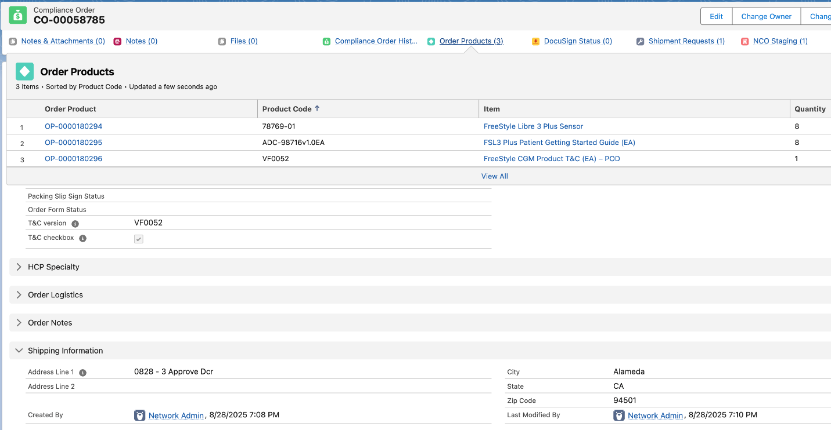

--
Raj Bhattacharjee
Veeva | Practice Manager, Commercial Technical Services

On Fri, Aug 29, 2025 at 8:36 AM Raj Bhattacharjee <raj.bhattacharjee@veeva.com> wrote:
Checking. Will keep you posted.

--
Raj Bhattacharjee
Veeva | Practice Manager, Commercial Technical Services

On Thu, Aug 28, 2025 at 6:59 PM Sharma, Anirudh <anirudh.sharma1@abbott.com> wrote:
Hi Raj,
Greetings!

We submitted two records for DCR approval and rejection. Krithika processed them, and here’s the status:
1. ✅ Rejection scenario (NCO-2558): Working as expected. The HCP account is tagged correctly with the appropriate data.
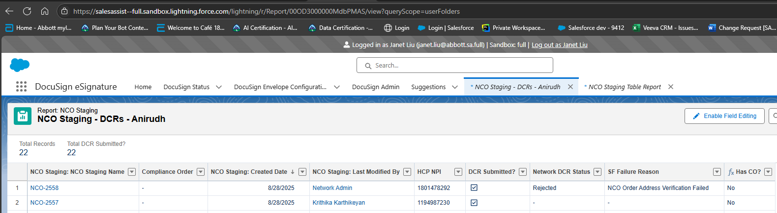

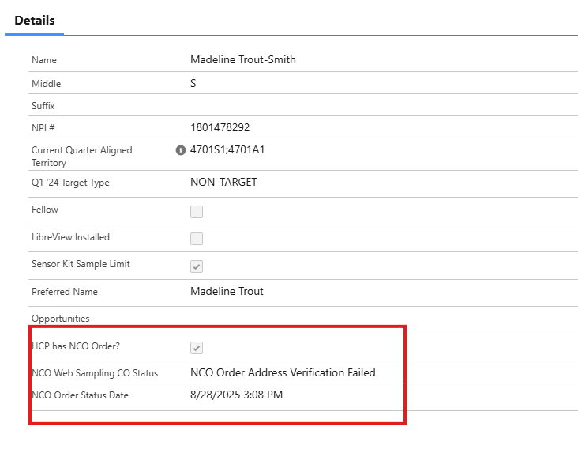
2. ❌ Approval scenario (NCO-2557): Not generating the Compliance Orders (COs) as expected.

Could you please assist us in resolving the issue with the approval scenario?
Best,
Anirudh

